
Discover Your Abilities. Get a Cool Job. Have a Great Life.
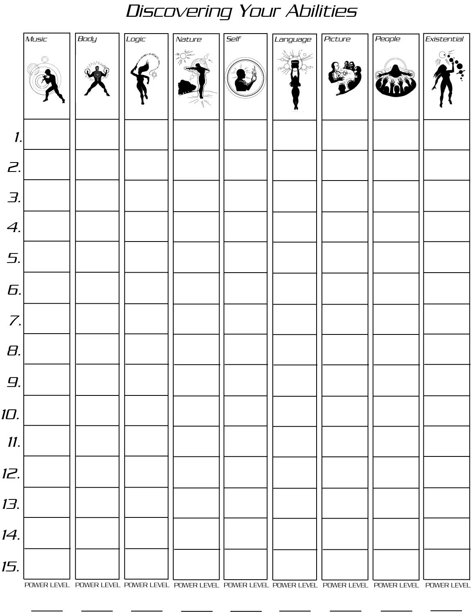
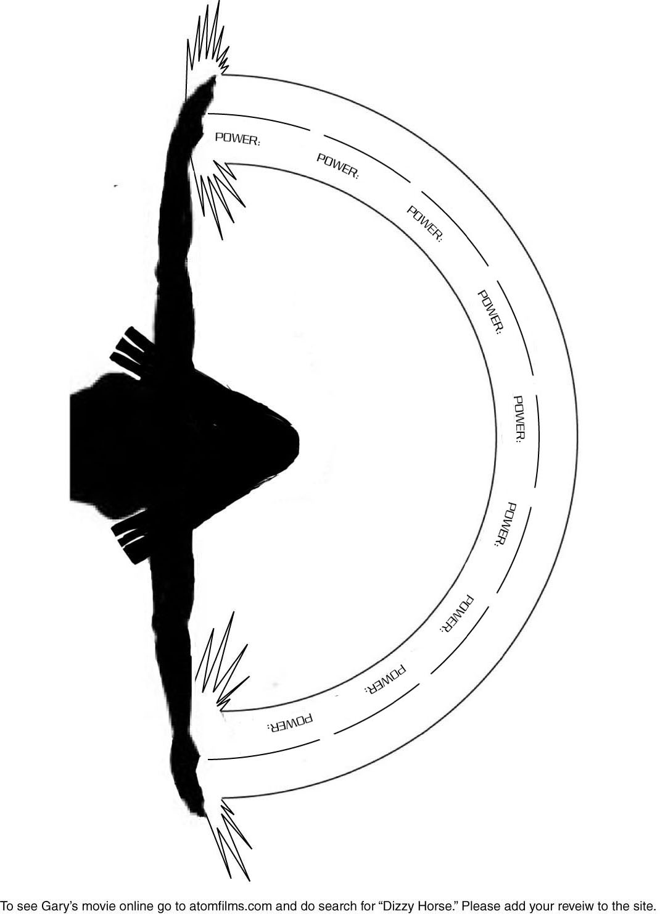
To learn about occupations that relate directly to your abilities, go to www.SuperHeroTraining.com

